
Full day sessions (7.30 am to 5.30pm) £35
Kings Heath Playcare
& half day sessions (7:30 am till 12.30 pm
October Half Term 2026
Please use the booking form on the reverse to select your usage. Return forms promptly to kingsheathplaycare@gmail.com
or 12.30 pm till 5.30 pm) £25
Shown are just a few of our activities on offer.

Thursday
29th October
Create a costume
Arts and Crafts
Scary science
Shadow puppets
Arts & Crafts

Cinema experience for all
Role play houses
Making book marks




Make a Monster
Monday
26th October
Arts and crafts
Pumpkin carving
Decorations

Cinema experience for all
Role play houses
Making book marks

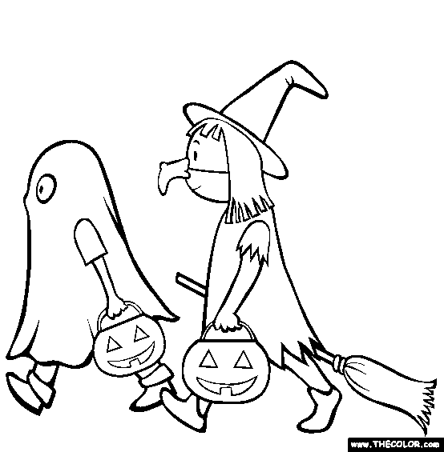


Wednesday
28th October
Arts and Craft
Monster Faces
Torch play outside

Cinema experience for all
Role play houses
Making book marks



Friday
30th October
Create a costume
Party Games
Arts and Crafts


Tuesday
27th October
Arts and crafts,
Sensory Play
Oreo Bats

Cinema experience for all
Role play houses
Making book marks



Fancy Dress Disco



We believe children’s play should be freely chosen and through play children explore the world and develop as an individual.
We believe in an inclusive play environment that is both stimulating and fun for all.

Please choose the days and sessions you would like to book, complete the forms and return to kingsheathplaycare@gmail.com in an with the subject October Half Term 2026 and your child’s name alternatively contact us for our banking details
(Please await confirmation of availability prior to making any payments)
Kings Heath Playcare C/O Kings Heath Primary School, Valentine Road, Kings Heath, Birmingham, B14 7AJ. 0121 444 5826
Please note that scheme operates a 7 working day cancelation policy, this must be emailed to (kingsheathplaycare@gmail.com) we do not offer refunds unless the payment is made in cash, all other payment methods will receive a credit on account.
Please note that full day sessions are priced at £35 (7.30 am to 5.30pm) and half day sessions are priced at £25 (7:30 am till 12.30 pm or 12.30 pm till 5.30 pm)
2026 | Mon 26th October | Tues 27th October | Wed 28th October | Thurs 29th October | Fri 30th October
Full Day
Morning

Afternoon

Please provide your child with a packed lunch if they are attending full day or morning sessions. Healthy snacks will be offered throughout the day. We endeavor to make our environment a ‘nut free’ environment due to children with allergies and ask for you to bear this in mind when providing your child’s packed lunch.

We operate a fining system for parents that collect their children after our sessions closure, this is priced at £2.00 per minute
Childs Name _______________________________ Parents name ______________________________ Contact No. ___________________________
Address ______________________________________________________ Signed Parent _____________________I enclose a payment of £___________ Payment Method_______________ Voucher Company___________________ If you are paying via any other method other than cash or cheque, please email proof of payment through to kingsheathplaycare@gmail.com prior to accessing. Please note we cannot refund voucher payments we can offer credit.

